Odd Semester (2021)



**BINUS UNIVERSITY**

**BINUS INTERNATIONAL**

**Assignment Cover Letter**

**(Individual Work****)**

|  |  |  |  |  |  |  |  |  |
| --- | --- | --- | --- | --- | --- | --- | --- | --- |
|  | | | | |  | |  | |
| **Student Information**: **Surname** | | | | | **Given Names**  **Christopher** | | **Student ID Number**  **2101693643** | |
| 1. | | **Turman** |  | |
|  |  |
| **Course Code** | **: COMP6502** |  |  | | **Course Name** | | **: Introduction to Programming** | |
| **Class** | **: L1BC-BLK** |  |  | | **Name of Lecturer(s)** | | **:** 1. Minaldi Loeis | |
|  |  |  |  | |  | | 2. Jude Martinez | |
| **Major** | **: CS** |  |  | |  | |  | |
| **Title of Assignment** | : Visual Novel Pygame | |  |  | |  | |  | |
| **Type of Assignment**    **Submission Pattern** | **: Final Project** |  |  | |  | |  | |
| **Due Date** | **: 6-11-2016** |  |  | | **Submission Date** | | **: 6-11-2016** | |

The assignment should meet the below requirements.

1. Assignment (hard copy) is required to be submitted on clean paper, and (soft copy) as per lecturer’s instructions.
2. Soft copy assignment also requires the signed (hardcopy) submission of this form, which automatically validates the softcopy submission.
3. The above information is complete and legible.
4. Compiled pages are firmly stapled.
5. Assignment has been copied (soft copy and hard copy) for each student ahead of the submission.

# Plagiarism/Cheating

Binus International seriously regards all forms of plagiarism, cheating and collusion as academic offenses which may result in severe penalties, including loss/drop of marks, course/class discontinuity and other possible penalties executed by the university. Please refer to the related course syllabus for further information.

# Declaration of Originality

By signing this assignment, I understand, accept and consent to Binus International terms and policy on plagiarism. Herewith I declare that the work contained in this assignment is my own work and has not been submitted for the use of assessment in another course or class, except where this has been notified and accepted in advance.

Signature of Student: (Name of Student)

1. Christopher Turman

**Visual Novel Pygame**

**Name :Christopher Turman**

**ID :2101693643**

1. **Prefixes**

To tell the truth, I’ve always been the type of guy who wanted to step outside my confort zone, moreover trying to creating something that represent myself. For this final exam I made a simple rpg in which player could go battle monster and so on like any rpg would but half way through the dev I bite more than I could chew, so I decided to ditch considering I’m in a deadlock position and left with 4 days to make and submitted to the lecturer.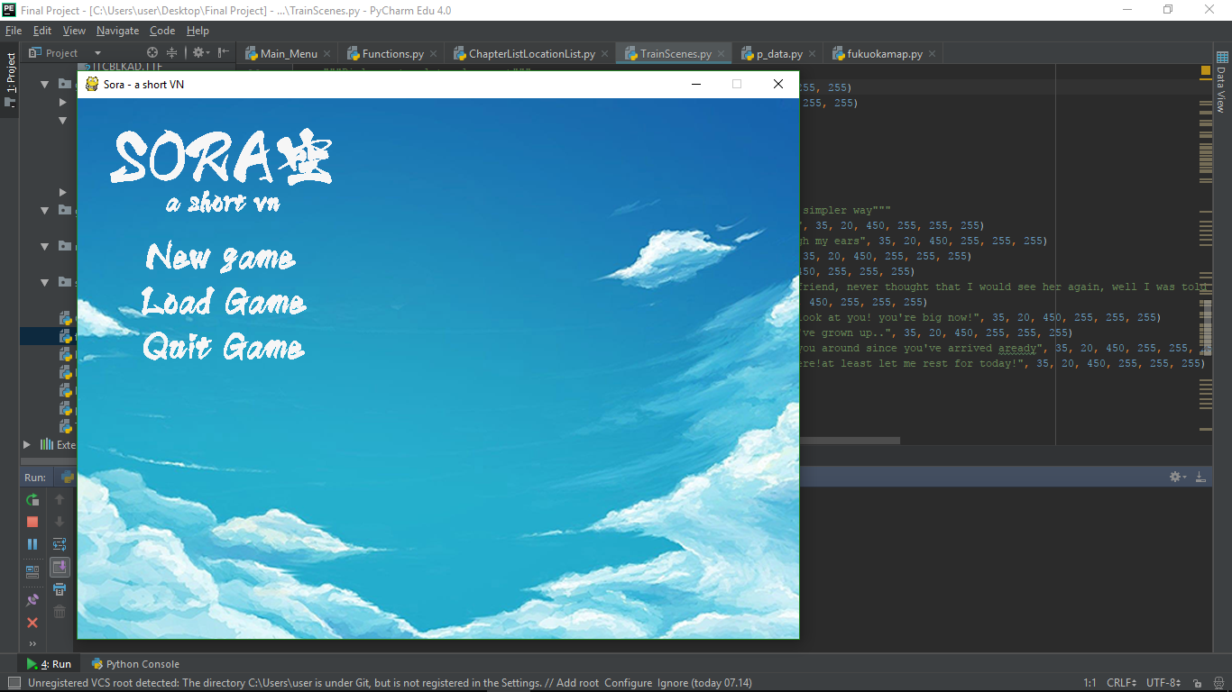 The VN itself are a simple one to code but repetitive and if aren’t carefully type would cause a lot of major error. The title of the game Sora which if you know japanese, it means sky. I originally plan the VN to have more character, picture manipulation (such as zoom in, zoom out, tremor, etc CGI), unique system (put battle system in it or maybe some minigame), insanely highly detailed main menu screen, more user friendly UI but as I can’t cover all, I’ve only managed to covered several endings only which is such a shame as I want to continue to make a lot better as I find it fun to code.

**II.a. Blueprint**

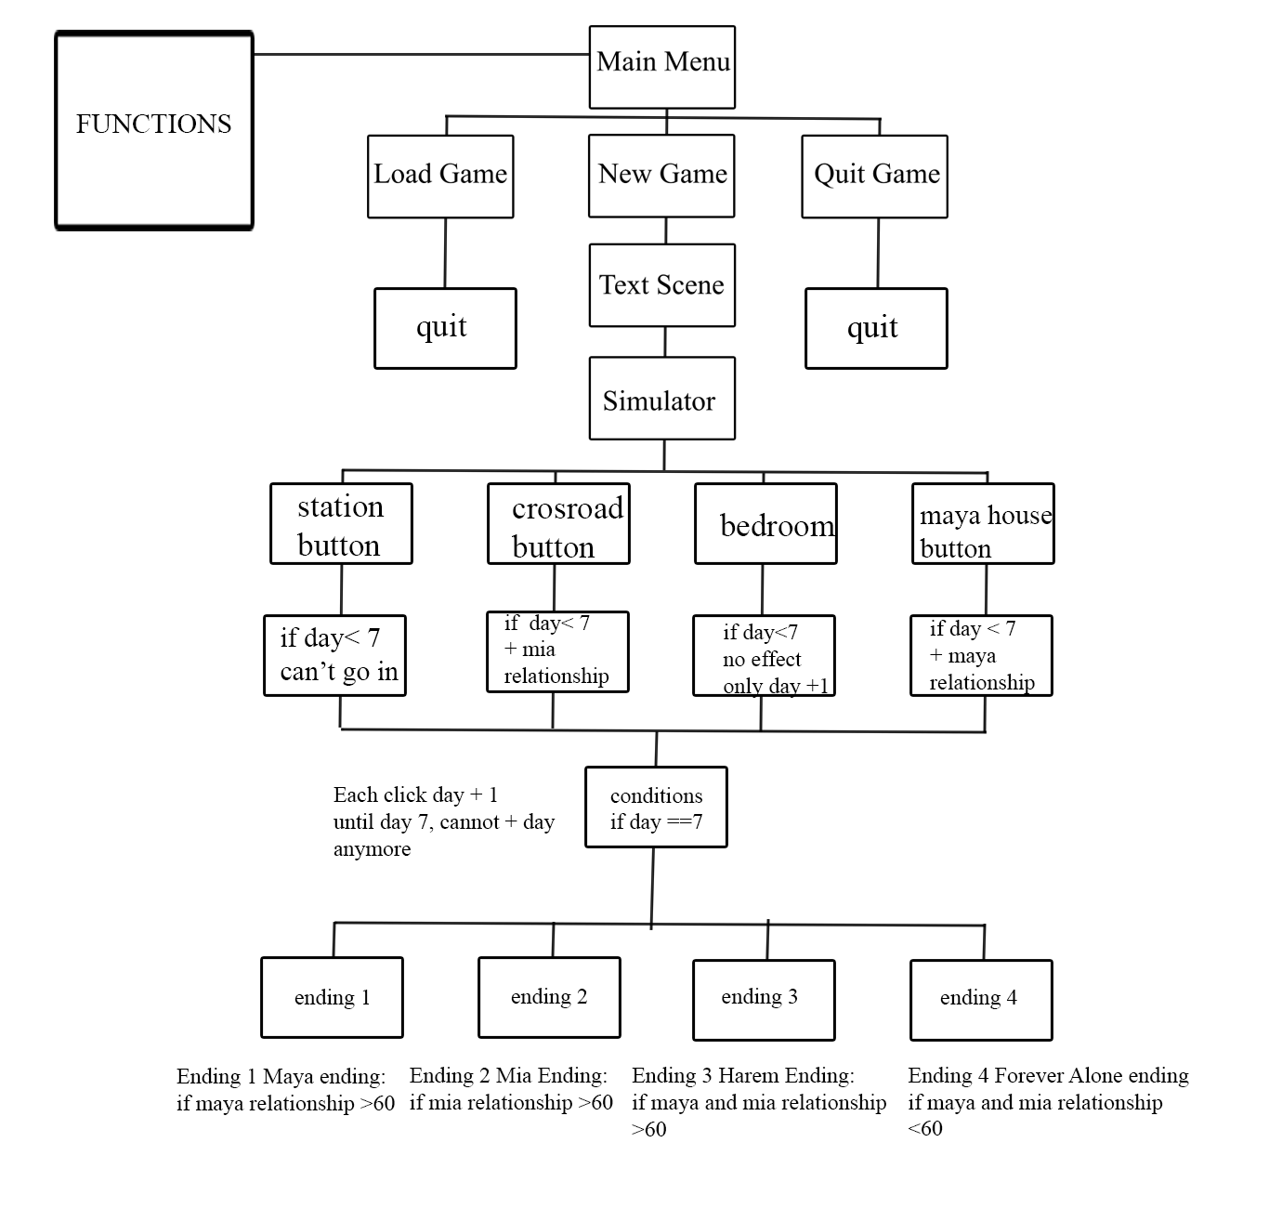

So how this work? Okay let’s start from the function and main menu, the functions.py are like a

shortcut library where I use the function to call images and sort of that stuffs. On the main menu

there are 3 button which is the new game, load game, and quit game. The load game and quit game

makes the player to quit game because the load game is only a dummy button.

If the player clicks new game, then the player are brought to scene in VN style, it’s fairly short one

but enough to show what to be expected from a basic VN, a background, bgm, sound effect, and

sprites. After finished with the scene, player will be playing some sort a prototype of sim game

where the player need to built the relationship of two bachelorettes which is Mayu and Mia.

I only make the game into 7 days so which mean the player can only have 6 actions before going

to leave for the endings. Each ending possesses several conditions such as the harem ending in

which you need to have 60 relationship points with both Mayu and Mia.

**II.b. Coder’s comment**

**Functions.py’s code: (basically life saving functions)**

***from pygame import *  
from pygame.sprite import \****

so first you need to import pygame and pygame.sprite because

1.you’re using pygame

2.you need pygame.sprite for obviously sprites

While import pygame are shorter and easier to remember, import * are way better due to * in import means you’re importing everything inside the file.

***class imagesprite(Sprite):  
  
 def __init__(self, filename, xpos, ypos):***

***Sprite.__init__(self)  
 self.image = image.load(filename)  
 self.rect = self.image.get_rect()  
 self.rect.x = xpos  
 self.rect.y = ypos***

Class imagesprite basically making an image and set it’s size and position, x and ypos determine of where will the image appears while self.rect is for getting the images’ size and image.load are function to load image.

***class textsprite(Sprite):  
  
 def __init__(self, fontstyle, text, fontsize, xpos, ypos, R, G, B):  
 Sprite.__init__(self)  
 self.font = pygame.font.SysFont(fontstyle, fontsize)  
 self.image = self.font.render(text, False, (R, G, B))  
 self.rect = self.image.get_rect()  
 self.rect.x = xpos  
 self.rect.y = ypos***

Textsprite are basically the same as imagesprite except it’s a text. ***def call_sprite(text, screen_type, mainscreen):  
  
  
 text_group = Group(text)  
 if screen_type == "Image":  
 text_group.draw(mainscreen.display)  
 if screen_type == "Fill":  
 text_group.draw(mainscreen.screen)***

one of the function I used a lot in this game, it’s a function to call image which saves me a lot of time. I only use 1 screen_type which is the “image” ones while the other one was originally used but then I delete some file in order to combine into one file.

***class MainScreen():  
  
 def __init__(self, imagefile):  
 clock=pygame.time.Clock()  
 displayw=800  
 displayh=600  
 self.display = pygame.display.set_mode((displayw, displayh))  
 pygame.display.set_caption("Sora - a short VN")  
 self.image = image.load(imagefile)  
 self.display.blit(self.image, (0,0))  
 clock.tick(120)***

It’s basically the usual initial set up after pygame.init. clock = pygame.time.Clock() is for later use in clock.tick(). clock.tick() is for FPS, so the higher the number you put in the higher the FPS be. In self.display basically making the screen itself while py.display.set_caption() are for setting the caption that usually on top.  
  
***class bgm():  
 def __init__(self, music):***

***pygame.mixer.music.load(music)***

***pygame.mixer.music.set_volume(0.5)***

***pygame.mixer.music.play(-1)***

mixer.music.load means to load the music, while set_volume is to set volume, and pygame.mixer.play(-1) is so that the music will keep repeating once it’s done

**Main.py’s code:**

***from Functions import *  
from pygame import \****

Import Functions.py aka my life saver as well as pygame as per usual

***pygame.init()***

pygame.init is a function you need to use to initialize pygame (basically to make pygame works)

***def mainmenuscreen():  
 bgm("music\\opening.mp3")***

defining the main menu screen as the function said, bgm is for music which I already covered in the Functions.py note

***while True:  
 mainscreen =MainScreen("graphics\\menu\\bgmenu.png")  
 logo = imagesprite("graphics\\menu\\bgtitle.png",10,20)  
 ngame = imagesprite("graphics\\menu\\ngame.png", 70, 150)  
 lgame = imagesprite("graphics\\menu\\lgame.png", 70, 200)  
 qgame = imagesprite("graphics\\menu\\qgame.png", 70, 250)  
 call_sprite(logo, "Image", mainscreen)  
 call_sprite(ngame, "Image", mainscreen)  
 call_sprite(lgame, "Image", mainscreen)  
 call_sprite(qgame, "Image", mainscreen)  
 display.update()***MainScreen is to define the background menu while imagesprite to set up the image. By using variables, imagesprites that have been defined then can be put inside call_sprite in it’s first argument (which I also already covered in the Functions.py) so that it knows where to put the sprite at. display.update basically to make all the sprite seen much like surface.blit()

***e = event.wait()***

***if ngame.rect.collidepoint(mouse.get_pos()):  
 if e.type == MOUSEBUTTONDOWN:  
 trainscene1()  
 if lgame.rect.collidepoint(mouse.get_pos()):  
 if e.type == MOUSEBUTTONDOWN:  
 pygame.quit()  
 break  
 if qgame.rect.collidepoint(mouse.get_pos()):  
 if e.type == MOUSEBUTTONDOWN:  
 pygame.quit()  
 break  
 if e.type == QUIT:  
 pygame.quit()  
 break***

okay so here’s how it goes, if (imagename).rec.collidepoint(mouse ….. BUTTONDOWN: means that when we do the event type like let’s take from the example above, MOUSEBUTTONDOWN means that so if I click the image, things happen.

Take example from ngame, if I click on ngame image, it’ll move to another function while if I click lgame or qgame, it’ll quit.

If e.type == QUIT: is for if you know the red button which usually in the same level as the caption? (basically the quit button) That’s QUIT, so everytime I press the button it’ll shut the app also keep note that it’ll only work on THIS FUNCTION.

***def trainscene1():  
 bgm("sfx\\subwaytrain.mp3")  
 mainscreen = MainScreen('graphics\\background\\trainstation.png')  
 textbox = imagesprite("gui\\textbox.png",0,0)***

basically the same as mainmenuscreen() where I would add bgm, background image and call image all that stuffs

***"""Sprite template placement"""  
 blanksprite = imagesprite("graphics\\character\\blanktemplate.png",-150,0)  
 blanksprite2 = imagesprite("graphics\\character\\blanktemplate.png",350,0)***

I call blanksprites with blank picture to make it a lot easier to access and format so that I only need to copy paste the code in here since the X and Y pos are already set

***"""Dialogue template placement"""  
 dialogueblank= textsprite("gamefont\\ITCBLKAD.TTF"," ", 35, 20, 480, 255, 255, 255)  
 dialogueblank2= textsprite("gamefont\\ITCBLKAD.TTF"," ", 35, 20, 510, 255, 255, 255)  
  
 '''Nametag template and character names'''  
 unknownname = textsprite("gamefont\\ITCBLKAD.TTF","???", 35, 20, 400, 255, 255, 255)  
 judemartinez = textsprite("gamefont\\ITCBLKAD.TTF","Jude Martinez", 35, 20, 400, 255, 255, 255)***

Basically the same as above since I wouldn’t want to scroll up and see where the y and x pos is.

***"""character dialogue, put in manually just so coz I can't find a better and simpler way"""  
 dialogue1= textsprite("gamefont\\ITCBLKAD.TTF","Ugh...", 35, 20, 450, 255, 255, 255)  
 dialogue2= textsprite("gamefont\\ITCBLKAD.TTF","What could possibly go much worse than this?", 35, 20, 450, 255, 255, 255)  
 dialogue3= textsprite("gamefont\\ITCBLKAD.TTF","I was living the barbie life of the grand lavish city of Tokyo.", 35, 20, 450, 255, 255, 255)  
 dialogue3a= textsprite("gamefont\\ITCBLKAD.TTF","but it has come to this? this rural stinky area? how did grandpa",35, 20, 480, 255, 255, 255)  
 dialogue3b= textsprite("gamefont\\ITCBLKAD.TTF","live this place anyway?",35, 20, 510, 255, 255, 255)  
 dialogue4= textsprite("gamefont\\ITCBLKAD.TTF","Oh my by the way, my name is Jude Martinez, everyone calls", 35, 20, 450, 255, 255, 255)  
 dialogue4a= textsprite("gamefont\\ITCBLKAD.TTF","me Jude. I was living in Tokyo but then stuffs happened and", 35, 20, 480, 255, 255, 255)  
 dialogue4b= textsprite("gamefont\\ITCBLKAD.TTF","here I am, in Fukuoka's countryside", 35, 20, 510, 255, 255, 255)  
 dialogue5= textsprite("gamefont\\ITCBLKAD.TTF","where my grandparent used to reside and my parent's hometown", 35, 20, 450, 255, 255, 255)  
 dialogue6= textsprite("gamefont\\ITCBLKAD.TTF","I'll be living here for the next 7 days for summer break", 35, 20, 450, 255, 255, 255)  
 dialogue7= textsprite("gamefont\\ITCBLKAD.TTF","I already miss tokyo...", 35, 20, 450, 255, 255, 255)  
 dialogue8= textsprite("gamefont\\ITCBLKAD.TTF","Oh well it's too late, it's almost Fukuoka...", 35, 20, 450, 255, 255, 255)  
 dialogue9= textsprite("gamefont\\ITCBLKAD.TTF","I guess I'll enjoy my stay in here for the next 7 days.", 35, 20, 450, 255, 255, 255)  
 counterdialogue = 0***

This was my last solution since I’m stuck for 4 hours when I code for the dialogue to work. So here’s the logic of my solution, first I call the dialogue as images, then after finish setting it up I make a variable which is counterdialouge. The variable are made so that for each click the text change how? If you look down below I’ve made the default variable for the nametag and so on so that it could easily changed.

***while True:  
  
 '''to make everything a lot easier, I use variable so there's no need to blit all the time'''  
 nametag = unknownname  
 character1= blanksprite  
 character2= blanksprite2  
 dialogueline1 = dialogue1  
 dialogueline2 = dialogueblank  
 dialogueline3 = dialogueblank2  
 e = event.wait()  
  
 '''counter dialogue so every click will change the text image only'''  
  
 if e.type == MOUSEBUTTONDOWN:  
 counterdialogue += 1  
 if counterdialogue == 1:  
 dialogueline1 = dialogue2  
 if counterdialogue == 2:  
 dialogueline1 = dialogue3  
 dialogueline2 = dialogue3a  
 dialogueline3 = dialogue3b  
 if counterdialogue ==3:  
 nametag = judemartinez  
 dialogueline1 = dialogue4  
 dialogueline2 = dialogue4a  
 dialogueline3 = dialogue4b  
 if counterdialogue ==4:  
 nametag = judemartinez  
 dialogueline1 = dialogue5  
 if counterdialogue ==5:  
 nametag = judemartinez  
 dialogueline1 = dialogue6  
 if counterdialogue ==6:  
 nametag = judemartinez  
 dialogueline1 = dialogue7  
 if counterdialogue ==7:  
 nametag = judemartinez  
 dialogueline1 = dialogue8  
 if counterdialogue ==8:  
 nametag = judemartinez  
 dialogueline1 = dialogue9  
 if counterdialogue ==9:  
 trainscene2()  
  
 '''call sprite is a basically function to show sprite such as blit but I found it easier'''  
  
 call_sprite(character1, "Image", mainscreen)  
 call_sprite(character2, "Image", mainscreen)  
 call_sprite(textbox, "Image", mainscreen)  
 call_sprite(dialogueline1, "Image", mainscreen)  
 call_sprite(dialogueline2, "Image", mainscreen)  
 call_sprite(dialogueline3, "Image", mainscreen)  
 call_sprite(nametag, "Image", mainscreen)  
 '''display update to update... yeah self explainatory, all I can say is without the update the screen won't show   
 any picture that have been blit/call'''  
  
 display.update()  
 if e.type == QUIT:  
 pygame.quit()  
 break  
  
def trainscene2():***

Again, the same as the other 2 function and could probably called the clone of trainscene1 because I was thinking to change the background but in the final preview I back down.

***'''  
 COPYPASTING EVERYWHERE (not from outsources, just copy pasting everything i've type hahah!)  
 '''  
 bgm("music\\cheerfulbgm.mp3")  
 mainscreen = MainScreen('graphics\\background\\trainstation.png')  
 textbox = imagesprite("gui\\textbox.png",0,0)  
  
 """Sprite template placement"""  
 blanksprite = imagesprite("graphics\\character\\blanktemplate.png",-150,0)  
 blanksprite2 = imagesprite("graphics\\character\\blanktemplate.png",350,0)  
  
  
 """Dialogue template placement"""  
 dialogueblank= textsprite("gamefont\\ITCBLKAD.TTF"," ", 35, 20, 480, 255, 255, 255)  
 dialogueblank2= textsprite("gamefont\\ITCBLKAD.TTF"," ", 35, 20, 510, 255, 255, 255)  
  
  
 """Character List and Images"""  
 maya = imagesprite("graphics\\character\\Maya\\mayanormal.png",-150,0)  
 mayahappy1 = imagesprite("graphics\\character\\Maya\\happy1.png",-150,0)  
 mayahappy2 = imagesprite("graphics\\character\\Maya\\happy2.png",-150,0)  
  
 '''Nametag template and character names'''  
 unknownname = textsprite("gamefont\\ITCBLKAD.TTF","???", 35, 20, 400, 255, 255, 255)  
 judemartinez = textsprite("gamefont\\ITCBLKAD.TTF","Jude Martinez", 35, 20, 400, 255, 255, 255)  
 mayaname = textsprite("gamefont\\ITCBLKAD.TTF","Maya", 35, 20, 400, 255, 255, 255)  
  
 """player's dialogue, put in manually just so because I can't find a better and simpler way"""  
 dialogue1= textsprite("gamefont\\ITCBLKAD.TTF","HEY!!! IT'S THAT YOU JUDE??", 35, 20, 450, 255, 255, 255)  
 dialogue2= textsprite("gamefont\\ITCBLKAD.TTF","A familiar voice rang through my ears", 35, 20, 450, 255, 255, 255)  
 dialogue3= textsprite("gamefont\\ITCBLKAD.TTF","Wait... is that you Maya?", 35, 20, 450, 255, 255, 255)  
 dialogue4= textsprite("gamefont\\ITCBLKAD.TTF","Yes! it sure is!", 35, 20, 450, 255, 255, 255)  
 dialogue5= textsprite("gamefont\\ITCBLKAD.TTF","That's Maya, my childhood friend, never thought that I", 35, 20, 450, 255, 255, 255)  
 dialogue5a= textsprite("gamefont\\ITCBLKAD.TTF","would see her again, well I was told by my mother", 35, 20, 480, 255, 255, 255)  
 dialogue5b= textsprite("gamefont\\ITCBLKAD.TTF","that she would be here", 35, 20, 510, 255, 255, 255)  
 dialogue6= textsprite("gamefont\\ITCBLKAD.TTF","So how's Mia?", 35, 20, 450, 255, 255, 255)  
 dialogue7= textsprite("gamefont\\ITCBLKAD.TTF","Shy as always but look at you! you're big now!", 35, 20, 450, 255, 255, 255)  
 dialogue8= textsprite("gamefont\\ITCBLKAD.TTF","Uhm... yes... of course, I've grown up..", 35, 20, 450, 255, 255, 255)  
 dialogue9= textsprite("gamefont\\ITCBLKAD.TTF","By the way, I should show you around since you've arrived aready!", 35, 20, 450, 255, 255, 255)  
 dialogue10= textsprite("gamefont\\ITCBLKAD.TTF","Wait but I just arrived here!at least let me rest for today!", 35, 20, 450, 255, 255, 255)  
 counterdialogue = 0  
 while True:  
 nametag = unknownname  
 character1= blanksprite  
 character2= blanksprite2  
 dialogueline1 = dialogue1  
 dialogueline2 = dialogueblank  
 dialogueline3 = dialogueblank2  
 e = event.wait()  
 if e.type == MOUSEBUTTONDOWN:  
 counterdialogue += 1  
 if counterdialogue == 1:  
 nametag = judemartinez  
 dialogueline1 = dialogue2  
 if counterdialogue == 2:  
 nametag = judemartinez  
 dialogueline1 = dialogue3  
 if counterdialogue ==3:  
 character1= mayahappy2  
 nametag = mayaname  
 dialogueline1 = dialogue4  
 if counterdialogue ==4:  
 nametag = judemartinez  
 character1= maya  
 dialogueline1 = dialogue5  
 dialogueline2 = dialogue5a  
 dialogueline3 = dialogue5b  
 if counterdialogue ==5:  
 nametag = judemartinez  
 dialogueline1 = dialogue6  
 if counterdialogue ==6:  
 character1= mayahappy1  
 nametag = mayaname  
 dialogueline1 = dialogue7  
 if counterdialogue ==7:  
 nametag = judemartinez  
 dialogueline1 = dialogue8  
 if counterdialogue ==8:  
 character1= mayahappy2  
 nametag = mayaname  
 dialogueline1 = dialogue9  
 if counterdialogue ==9:  
 nametag = judemartinez  
 dialogueline1 = dialogue10  
  
 call_sprite(character1, "Image", mainscreen)  
 call_sprite(character2, "Image", mainscreen)  
 call_sprite(textbox, "Image", mainscreen)  
 call_sprite(dialogueline1, "Image", mainscreen)  
 call_sprite(dialogueline2, "Image", mainscreen)  
 call_sprite(dialogueline3, "Image", mainscreen)  
 call_sprite(nametag, "Image", mainscreen)  
  
 if counterdialogue ==10:  
 simmenu()  
 display.update()  
  
 if e.type == QUIT:  
 pygame.quit()  
 break  
  
  
def simmenu():  
 bgm("music\\p4alone.mp3")  
 '''number of days and relationship system are basically have the same logic as the text system'''  
 mainscreen =MainScreen("graphics\\menu\\bgmenu.png")  
 background =imagesprite("graphics\\button\\mainsim.png",0,0)  
 numday = "Day 1"  
 numday2 = "Day 2"  
 numday3 = "Day 3"  
 numday4 = "Day 4"  
 numday5 = "Day 5"  
 numday6 = "Day 6"  
 numday7 = "Day 7"  
 dayongame = numday  
 trainbutton1= textsprite("gamefont\\ITCBLKAD.TTF","It's not time to leave yet", 35, 20, 450, 255, 255, 255)  
 trainbutton2= textsprite("gamefont\\ITCBLKAD.TTF","Today is my last day, I should go to the train station", 35, 20, 450, 255, 255, 255)  
 choosingaction= textsprite("gamefont\\ITCBLKAD.TTF","what should I do for today?", 35, 20, 450, 255, 255, 255)  
 textbox = imagesprite("gui\\textbox.png",0,0)  
 miarelationship = 0  
 mayarelationship = 0  
 day = 1  
 while True:  
 button1=imagesprite("graphics\\button\\buttontrainstation.png",450,50)  
 button2=imagesprite("graphics\\button\\mayahouse.png",30,50)  
 button3=imagesprite("graphics\\button\\crossroad.png",30,200)  
 button4=imagesprite("graphics\\button\\bedroom.png",450,200)  
 days=textsprite("gamefont\\ITCBLKAD.TTF",dayongame, 35, 350, 370, 255, 255, 255)  
 strmayarelationship = "Maya relationship:"+ str(mayarelationship)  
 strmiarelationship = "Mia relationship:"+ str(miarelationship)  
 relationship1 = textsprite("gamefont\\ITCBLKAD.TTF",strmayarelationship, 35, 50, 0, 255, 255, 255)  
 relationship2 = textsprite("gamefont\\ITCBLKAD.TTF",strmiarelationship, 35, 450, 0, 255, 255, 255)***

Okay a lot to be said in here but before to clarify, I want to said that the day was suppose to be have the same logic with the relationship but I know why it turn out to be like that. Basically the combine version of mainmenuscreen and trainscene1 and 2 with showing the Variable. The logic is fairly simple so to show the progress, just make a variable(ex/relationship) in number and make a new variable to define the number as strings using str(), lastly put it inside textsprites.

***chooseaction=choosingaction  
 e= event.wait()  
 '''so if day before 7 == you still can do action coz at the end of the week you'll be going home'''  
 if day<7:  
 if button1.rect.collidepoint(mouse.get_pos()):  
 if e.type == pygame.MOUSEBUTTONDOWN:  
 chooseaction = trainbutton1  
 if button2.rect.collidepoint(mouse.get_pos()):  
 if e.type == pygame.MOUSEBUTTONDOWN:  
 day += 1  
 mayarelationship += 20  
 if button3.rect.collidepoint(mouse.get_pos()):  
 if e.type == pygame.MOUSEBUTTONDOWN:  
 day += 1  
 miarelationship += 20  
 if button4.rect.collidepoint(mouse.get_pos()):  
 if e.type == pygame.MOUSEBUTTONDOWN:  
 day += 1  
 if day == 2:  
 dayongame = numday2  
 if day == 3:  
 dayongame = numday3  
 if day == 4:  
 dayongame = numday4  
 if day == 5:  
 dayongame = numday5  
 if day == 6:  
 dayongame = numday6  
 if day == 7:  
 dayongame = numday7  
 if day == 7:  
 chooseaction = trainbutton2  
 if button1.rect.collidepoint(mouse.get_pos()):  
 if e.type == pygame.MOUSEBUTTONDOWN:  
 if mayarelationship >60:  
 mayaending()  
 elif miarelationship>60:  
 miaending()  
 elif mayarelationship == 60 and miarelationship == 60:  
 haremending()  
 else:  
 aloneending()***

Basically same as mainmenuscreen() button function except with every click unto the button instead of moving to another function or quitting, it changes the variable. I make so that the before day 7 you can only click 3 buttons to make the day move on as it seen on the code, if you try to click the trainstation button it’ll only show it’s not time to leave yet. Moving on, if you click until the 7th day, you can only go to the trainstation to show the ending which each have the condition.

Maya ending needs her relationship to be 60 or above, Mia ending needs her relationship to be 60 or above as well, Harem ending would mean that the player need to have 60 for each Maya and Mia and lastly a secret ending which if you don’t achieve 60 in any of the girls you’ll get forever alone ending.

***call_sprite(background, "Image", mainscreen)  
 call_sprite(button1, "Image", mainscreen)  
 call_sprite(button2, "Image", mainscreen)  
 call_sprite(button3, "Image", mainscreen)  
 call_sprite(button4, "Image", mainscreen)  
 call_sprite(textbox, "Image", mainscreen)  
 call_sprite(chooseaction, "Image", mainscreen)  
 call_sprite(relationship1, "Image", mainscreen)  
 call_sprite(relationship2, "Image", mainscreen)  
 call_sprite(days,"Image", mainscreen)  
 display.update()  
  
 if e.type == QUIT:  
 pygame.quit()  
 break  
  
def mayaending():  
 while True:  
 mainscreen =MainScreen("graphics\\Ending\\maya.png")  
 text= textsprite("gamefont\\ITCBLKAD.TTF","Maya's Ending", 70, 225, 270, 0, 0, 0)  
 call_sprite(text, "Image", mainscreen)  
 e= event.wait()  
 if e.type == MOUSEBUTTONDOWN:  
 mainmenuscreen()  
 display.update()***

just a simple scene, where I only code the background image along with the ending title.

***if e.type == QUIT:  
 pygame.quit()  
def miaending():  
 while True:  
 mainscreen =MainScreen("graphics\\Ending\\mia.png")  
 text= textsprite("gamefont\\ITCBLKAD.TTF","Mia's Ending", 70, 225, 270, 255, 255, 255)  
 call_sprite(text, "Image", mainscreen)  
 e= event.wait()  
 if e.type == MOUSEBUTTONDOWN:  
 mainmenuscreen()  
 display.update()  
  
 if e.type == QUIT:  
 pygame.quit()  
  
def haremending():  
 bgm("music\\kill.mp3")  
 while True:  
 mainscreen =MainScreen("graphics\\Ending\\harem.png")  
 text= textsprite("gamefont\\ITCBLKAD.TTF","Harem Ending", 70, 225, 270, 255, 0, 0)  
 call_sprite(text, "Image", mainscreen)  
 e= event.wait()  
 if e.type == MOUSEBUTTONDOWN:  
 mainmenuscreen()  
 display.update()  
  
 if e.type == QUIT:  
 pygame.quit()  
  
def aloneending():  
 bgm("music\\sadviolin.mp3")  
 while True:  
 mainscreen =MainScreen("graphics\\Ending\\alone.png")  
 text= textsprite("gamefont\\ITCBLKAD.TTF","Forever Alone Ending", 70, 130, 250, 255, 255, 255)  
 call_sprite(text, "Image", mainscreen)  
 e= event.wait()  
 if e.type == MOUSEBUTTONDOWN:  
 mainmenuscreen()  
 display.update()  
  
 if e.type == QUIT:  
 pygame.quit()  
  
mainmenuscreen()***

basically to start the app

***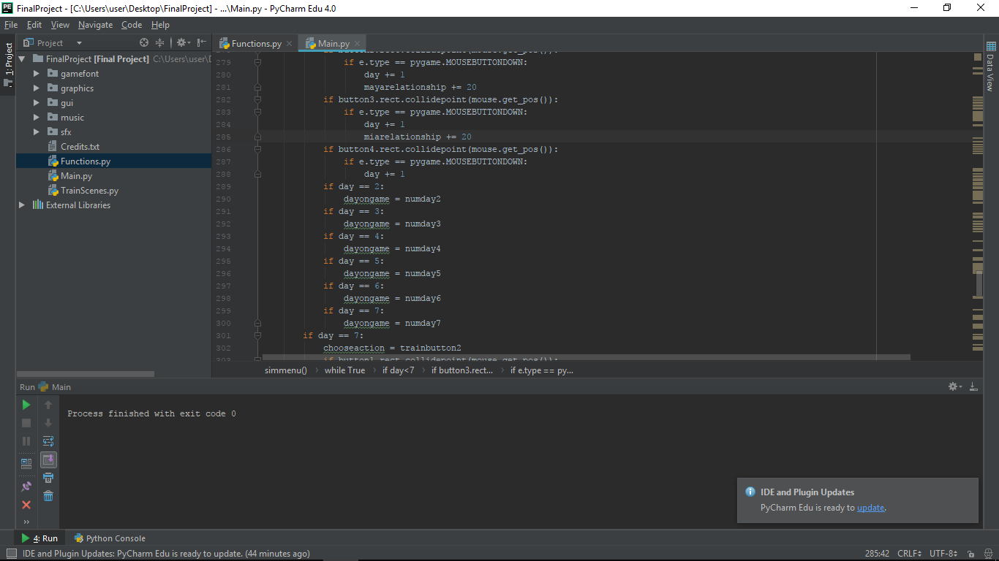*III.a. Reverse Progress Diary (forgot to screenshot everything, so a bit incomplete)**

5th of November,

Taking the most recent as the top spot as I need to learn that I need BACKUP, first of all as I wanted to finished the project, pycharm crashed which lead to my pygame project to almost corrupted. Thankfully nothing big happened, although I need to rearrange a lot of stuff such as combining several files into one so that it works.

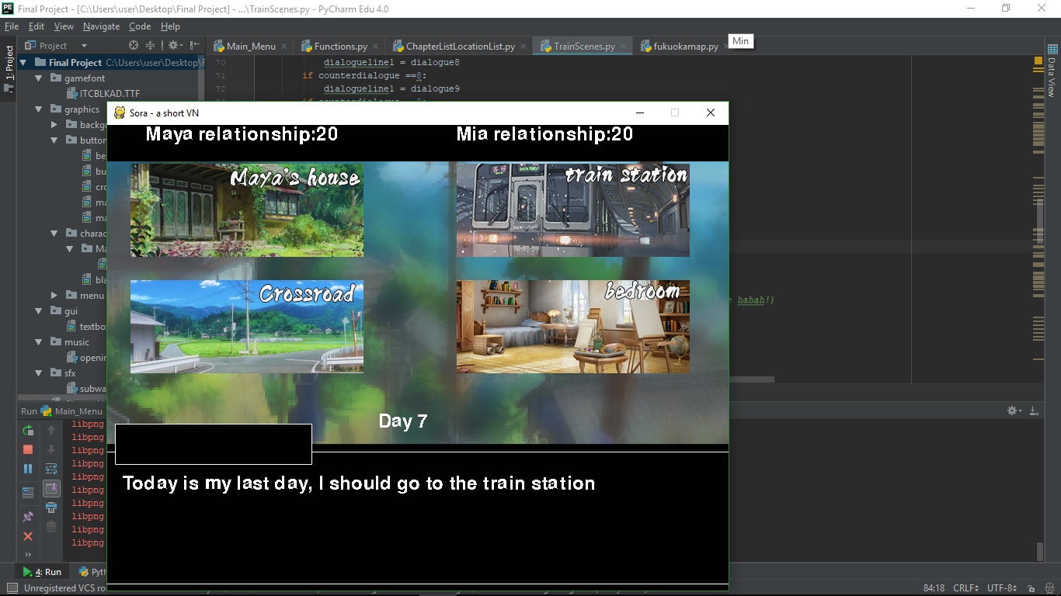

4th of October,

Do not take anything to lightly, I initially thought that coding the textbox are easy, my past logic was to make the text in the textbox to change just by stacking *if event.wait().type == MOUSEBUTTONDOWN:* which only lead to just quick changes but I’ve learned that there’s another way although it took really long but a lot more effective

3th of October,

The first day I officially code this game, I create the menu thinking this will be the easiest code that I will do besides print(“hello world”). Nothing major happens really

2nd of October,

After devastated that I couldn’t make my RPG works, I’ve begun to brainstorming on what would I do next as I doesn’t know what to do or what to make considering I have no knowledge of Django at all or willing to make app with Django nor to get at most c with text based.

1st of October,

Got deadlocked after seemingly can’t make the game works at all, I decided to scrap it before it’s too late to change.

**III.b. Challenges**

Never thought that I could done this final project but here I am, writing this up as I finished the game that I’ve made in a short period of times. When it was first announced, I was hyped as it’s one of my dream to make game of my own. I was really ambitious and take the idea of RPG, at first, it went well, I have the sprites and so on until one moment, where the code suddenly doesn’t work. I was in state of panic because it was one week worth of my time but luckily due to my quick decision I decided to ditch the project (which I would love to continue later on) and rework my game from beginning as VN.

**IV. Credits**

*BACKGROUND PICTURES:*

Google, credits to its respective artist

*CHARACTER SPRITES:*

Ayase Hazuki | found it on DA and the person said to credit to Ayase Hazuki

*BACKGOUND MUSICS:*

-Lia - One (RISING FORCE INTRO MUSIC)

-Persona OST - Alone

-Cheerful Anime Tune: A Small Romance |https://www.youtube.com/watch?v=gCVuwJzaVn8

-Sad Romance - Over green fields OST

-Rose are red, violets are blue, omae wa mo shindeiru | https://www.youtube.com/watch?v=Dq5akYdtW6E

SFX:

-INSIDE SUBWAY TRAIN SFX | LINK:https://www.youtube.com/watch?v=KKxWwLRKcjA